 | Tikrit Journal of Veterinary Science | 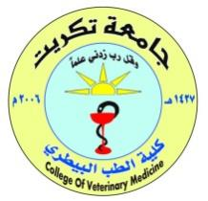

Antimicrobial Resistance in Bacterial Pathogens of Poultry: Current Knowledge, Challenges, and Future Perspectives — A Narrative Review

Hesham …….¹, Hesham …….², and Hesham …….³

¹Department of …………, Veterinary Medicine College, University of Tikrit, Tikrit, Iraq
²Department of …………, Veterinary Medicine College, University of Tikrit, Tikrit, Iraq
³Department of …………, Veterinary Medicine College, University of Tikrit, Tikrit, Iraq

A r t i c l e i n f o.  Article history:  -Received:  -Received In Revised Form:  -Accepted:  -Available online:  Keywords:  Antimicrobial resistance; Poultry; Bacterial pathogens; Antimicrobial use; Veterinary medicine.  ـــــــــــــــــــــــــــــــــــــــــــــــ  Corresponding Author:  Name: Hesham ……..  E-mail:  00000000@tu.edu.iq  Tel: 078200000000 | ABSTRACT  Background: Antimicrobial resistance is an increasing concern in veterinary medicine, particularly in bacterial diseases of poultry.  Objective: This review summarizes current evidence regarding antimicrobial resistance in major bacterial pathogens affecting poultry.  Literature Overview: The review discusses major bacterial pathogens associated with poultry diseases, commonly reported resistance patterns, mechanisms of resistance, and factors associated with antimicrobial use in poultry production.  Conclusions: Understanding antimicrobial resistance patterns and their contributing factors is important for improving disease management, strengthening surveillance, and supporting the responsible use of antimicrobial agents in poultry production.

INTRODUCTION
What is the topic?
Why is it important?
What is already known?
What is still unclear or missing?
What is the objective of this review?
Example: Antimicrobial resistance represents an increasing challenge in veterinary medicine and may compromise the effectiveness of commonly used antimicrobial agents. Poultry-associated bacterial pathogens have demonstrated variable resistance patterns across geographical regions and bacterial species. Although numerous studies have investigated antimicrobial resistance in poultry, the available evidence remains dispersed across different pathogens, antimicrobial classes, and production systems. Therefore, this review aims to summarize and critically discuss the current evidence regarding antimicrobial resistance in major bacterial pathogens affecting poultry.
Or
General Background
Scientific Importance
Current Knowledge
Knowledge Gap
Review Objective
LITERATURE SEARCH / SEARCH STRATEGY
Example: Relevant literature on antimicrobial resistance in poultry-associated bacterial pathogens was identified through searches of scientific databases, including PubMed, Scopus, and Web of Science, where available. Search terms included combinations of the following keywords: antimicrobial resistance, antibiotic resistance, poultry, bacterial pathogens, antimicrobial susceptibility, and antimicrobial use.
The review focused on publications addressing antimicrobial resistance in bacterial pathogens associated with poultry health, resistance mechanisms, antimicrobial susceptibility patterns, and approaches to antimicrobial stewardship. Relevant review articles and original research studies were considered to provide an overview of the available evidence.
The findings were organized thematically to facilitate comparison between bacterial pathogens, resistance mechanisms, and factors associated with antimicrobial resistance.
Antimicrobial resistance (AMR) is a major concern in veterinary medicine because it may compromise the effectiveness of antimicrobial agents used to treat bacterial infections in animals. In poultry production, bacterial diseases can affect animal health, productivity, and the economic sustainability of production systems (Ali, 2026). Several bacterial pathogens are associated with important diseases in poultry, and their antimicrobial susceptibility may vary according to bacterial species, geographical region, production system, and patterns of antimicrobial use. Understanding these differences is important for selecting appropriate treatment strategies and developing effective antimicrobial stewardship programs (Ali et al., 2026).
Although antimicrobial resistance has been investigated in numerous veterinary studies, the available evidence may differ in terms of bacterial species, sampling methods, antimicrobial susceptibility testing procedures, and interpretation criteria. These differences should be considered when comparing findings across studies (Ali and Qussai, 2026).
Therefore, this narrative review aims to summarize and critically discuss current knowledge of antimicrobial resistance in major bacterial pathogens affecting poultry, with particular emphasis on resistance mechanisms, factors associated with resistance, implications for poultry health, and potential strategies to improve antimicrobial stewardship (Ali et al., 2026).
Databases
Search Terms
Scope
Types of Sources
Organization
MAIN TOPIC
Major Bacterial Pathogens Associated with Poultry Diseases
Several bacterial pathogens are associated with clinically important diseases in poultry. These may include Escherichia coli, Salmonella spp., Staphylococcus aureus, and Pasteurella multocida. Their clinical significance varies according to the disease involved, the affected poultry population, and the production environment.
When reviewing antimicrobial resistance in these organisms, it is important to distinguish between bacterial pathogens associated with clinical disease and bacteria detected in apparently healthy birds or production environments. The source of the isolate and the clinical context should therefore be considered when interpreting published findings.
Antimicrobial Resistance Patterns
Antimicrobial resistance patterns should be examined separately for each bacterial species and antimicrobial class. Studies may report different susceptibility profiles depending on the origin of the isolates, the geographical region, the sampling strategy, and the laboratory methods used.
When comparing published findings, reviewers should identify whether studies used comparable antimicrobial susceptibility testing methods and interpretive criteria. Differences between studies should not automatically be attributed to biological changes in resistance because methodological differences may also contribute to the observed variation.
Mechanisms of Antimicrobial Resistance
Antimicrobial resistance may arise through several mechanisms, including enzymatic inactivation of antimicrobial agents, changes in antimicrobial targets, reduced permeability of bacterial cells, and active efflux of antimicrobial compounds. Some bacteria may also acquire resistance determinants through horizontal gene transfer.
The mechanisms involved vary according to the bacterial species and antimicrobial class. Consequently, the detection of a resistance phenotype does not always establish the specific molecular mechanism responsible for that phenotype. Molecular and phenotypic findings should be interpreted together when both are available.
Factors Associated with Antimicrobial Resistance and Control Strategies
Several factors may influence antimicrobial resistance in poultry production, including antimicrobial selection pressure, infection prevention practices, biosecurity, farm management, and the circulation of resistant bacteria between animals and their environments.
Control strategies discussed in the literature include improving farm hygiene and biosecurity, strengthening disease prevention and vaccination programs where appropriate, using diagnostic testing to support treatment decisions, and implementing antimicrobial stewardship. The potential effectiveness of these strategies should be evaluated in light of the available evidence and the conditions under which each study was conducted.
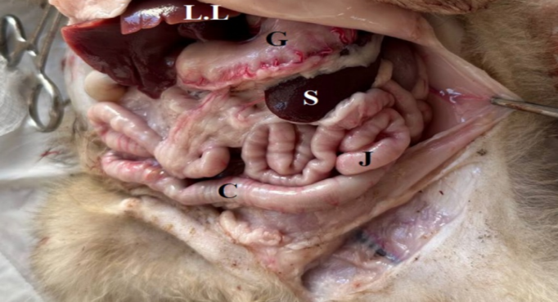

Fig. 1. Photography of the Abdominal cavity of puppies at 2-week (A): illustrated the position spleen (S), in left side, stomach (G) liver lobes (LL), Jejunum (J), colon (C).
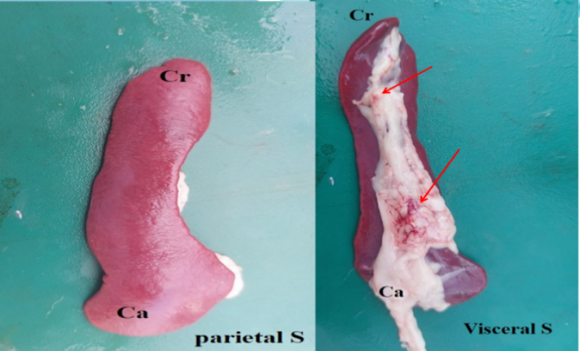

Fig. 2. Photography of the spleen (S) of puppies at 4 weeks as illustrated the parietal surface and visceral surface, hillus (red arrow).
The spleen was elongated, Crescent in shape, brown-reddish in color, it had two surfaces (parietal and visceral) (Figure 2), The parietal surface was concave, curved, and smooth (Figure 2 A), whereas the visceral surface had the hilus. (Figure 2 B), the weighted 10.87 ±2.77g,12.16 ±2.67g and 16.60 ±3.94. The body of the spleen has two ends (cranial and caudal), the wide cranial ends were 12.39 ±3.55 mm,12.99 ±2.74 mm, and 13.12 ± 4.76 mm, respectively, whereas the caudal ends19.78 ±2.25, mm,20.6 ±4.98 mm, and 25.2 ±0.57 mm, respectively. The caudal end is wider than the cranial. But there were no differences in shape and color between the spleens at three weeks of age. Whereas the thickness of the spleen was not uniform in all body, it is thicker in caudal end the cranial endless the body (Table 1 and Figure 2).
The branched inside the parenchyma, which subdivided into multiple branches at the hilum of the spleen, characterize have hillus along the body receive the blood through splenic artery which raise from celiac artery, the spleen related with the jejunum, stomach (Figure 3).

Table 1. The measurement of the spleen of the puppies at three (2,4 and 8) weeks of ages
Parameters | Mean ± SD |  |  | L.S.D.
Parameters | 2 weeks | 4 weeks | 8 weeks | L.S.D.
Length of spleen (mm) | 8.20 ±0.67 b | 9.32 ±2.67 b | 18.072 ±4.45 a | 2.901 *
Weight of the spleen (g) | 10.87 ±2.77 b | 12.16 ±2.67 b | 16.60 ±3.94 a | 3.047 *
Thick of body (mm) | 4.52 ±1.32 b | 6.55 ±2.95 a | 6.70 ± 2.66 a | 1.895 *
Thick carinal end (mm) | 12.39 ±3.55 a | 12.99 ±2.74 a | 13.12 ± 4.76 a | 2.077 NS
Thick caudal end (mm) | 19.78 ±2.25 a | 20.6 ±4.98 a | 25.2 ±0.57 b | 4.029 *
Means having with the different letters in same row differed significantly. * (P<0.05).

EVIDENCE SYNTHESIS / DISCUSSION
The available literature on antimicrobial resistance in poultry-associated bacterial pathogens should be interpreted in the context of differences in bacterial species, geographical distribution, production systems, and laboratory methods. Although individual studies may report resistance to particular antimicrobial classes, direct comparisons between studies require careful consideration of the methods used to obtain and interpret the results (Ali and Qussai, 2026) and golden Hamster (Ali, 2026).
Differences in antimicrobial susceptibility testing procedures, sampling strategies, and interpretive criteria may limit the comparability of findings. In addition, studies conducted in a single farm or geographical region may not represent the resistance patterns present in other poultry production systems (Ali et al., 2026).
An important consideration is the distinction between detecting antimicrobial resistance and identifying the mechanisms responsible for it. Phenotypic susceptibility testing provides information about the response of bacterial isolates to antimicrobial agents, whereas molecular investigations may help identify specific resistance determinants. Combining these approaches, when appropriate, can provide a more comprehensive understanding of resistance.
The evidence also highlights the importance of interpreting antimicrobial resistance within the broader context of poultry health management. Biosecurity, disease prevention, appropriate diagnostic testing, and responsible antimicrobial use are relevant components of control programs. However, the effectiveness of individual interventions should be evaluated using evidence from appropriately designed studies rather than assumed from their theoretical benefits alone.
Several knowledge gaps may warrant further investigation, including differences in surveillance methods, the geographical distribution of resistant bacterial populations, and the relationship between antimicrobial use and resistance patterns under different production conditions. Future studies using standardized methods and clearly defined sampling strategies could improve the comparability of findings and support more reliable surveillance.
Synthesis of Evidence
Critical Comparison
Interpretation
Strengths and Limitations
Knowledge Gaps
Implications
Future Research
CONCLUSION
Antimicrobial resistance in bacterial pathogens affecting poultry is a complex issue that requires interpretation in the context of bacterial species, production systems, geographical differences, and laboratory testing methods. A critical assessment of the available literature is essential for identifying consistent findings, recognizing limitations in the evidence, and understanding current knowledge gaps. Improved surveillance, standardized antimicrobial susceptibility testing, effective biosecurity, disease prevention, and responsible antimicrobial use are important areas for continued attention. Further research using comparable methods and clearly defined study populations may help strengthen the evidence base and support more effective antimicrobial stewardship in poultry production.
What is the main message?
Why does it matter?
What should happen next?
Conflict of interest
The authors assert the absence of any conflicts of interest.
Acknowledgements
The authors express gratitude to the members of the Department of Anatomy & Histology, College of Veterinary Medicine, University of Diyala, for their collaboration.
Declaration of interests
The authors have no conflicts of interest to declare.
Funding Sources
This research received no specific grant from any funding agency in the public, commercial, or not-for-profit sectors.
Publication consent
The authors agree to publication.
Data and material availability
All data analyzed during this study are included in this article.
Author contribution
The authors contributed equally to the article.
REFERENCES
Bancroft, A. J., McKenzie, A. N., & Grencis, R. K. (1998). A critical role for IL-13 in resistance to intestinal nematode infection. The Journal of Immunology, 160(7), 3453–3461. doi:org/10.4049/jimmunol.160.7.3453
Brendolan, A., Rosado, M. M., Carsetti, R., Selleri, L., & Dear, T. N. (2007). Development and function of the mammalian spleen. BioEssays, 29(2), 166–177. doi:org/10.1002/bies.20528
Das, S. K., Alam, M. S., Islam, M. N., & Awal, M. A. (2005). Histology of the spleen of indigenous dog (Canis familiaris) of Bangladesh. Bangladesh Journal of Veterinary Medicine, 3(1), 59–61. doi:org/10.3329/bjvm.v3i1.11356
George, D., & Mallery, P. (2019). IBM SPSS Statistics 26 step by step: A simple guide and reference (16th ed.). Routledge. doi:org/10.4324/9780429056765
Khalel, E. M. (2010). Anatomical and histological study of the spleen in Iraqi sheep (Awasi sheep). Basrah Journal of Veterinary Research, 9(2), 163–171. doi:org/10.33762/bvetr.2010.55061
Mebius, R. E., & Kraal, G. (2005). Structure and function of the spleen. Nature Reviews Immunology, 5(8), 606–616. doi:org/10.1038/nri1669
Young, B., & Heath, J. W. (2000). Wheater’s functional histology (4th ed.). Churchill Livingstone, London.

دراسة مورفولوجية وكيميائية نسيجية للطحال في الجراء بعد الولادة

هشام منعم نصيف ¹, رباب عبد الامير ناصر ²
^{2،1} فرع التشريح وعلم الأنسجة، كلية الطب البيطري، جامعة ديالى، العراق

الملخص
خلفية البحث: حظيت النباتات الطبية ومركباتها الفعالة حيويًا باهتمام متزايد بوصفها مكملات طبيعية محتملة في مجال الطب البيطري. ويحتوي قشر الليمون على العديد من المركبات الفعالة حيويًا التي قد تؤثر في المؤشرات الدموية والكيميائية الحيوية.
الهدف: هدفت هذه الدراسة إلى تقييم تأثير المستخلص الميثانولي لقشر الليمون في بعض المؤشرات الدموية، ومعايير الصفائح الدموية، والمؤشرات الكيميائية الحيوية لدى الأرانب الذكور السليمة.
المواد وطرق العمل: استُخدمت عشرة أرانب ذكور سليمة، وقُسّمت عشوائيًا إلى مجموعتين: مجموعة سيطرة ومجموعة معاملة بالمستخلص، بواقع خمس حيوانات في كل مجموعة. تلقت مجموعة المعاملة المستخلص الميثانولي لقشر الليمون بجرعة مقدارها ٥٠ ملغم لكل كيلوغرام من وزن الجسم، عن طريق الفم، مرة واحدة يوميًا لمدة ٦٠ يومًا. جُمعت عينات الدم لتقييم المؤشرات الدموية، ومعايير الصفائح الدموية، وملف الدهون، ومؤشرات وظائف الكبد والكلى.
النتائج: ارتبط إعطاء مستخلص قشر الليمون بحدوث تغيرات في بعض مؤشرات الصفائح الدموية، ومعايير ملف الدهون، وفعاليات إنزيمات الكبد مقارنةً بمجموعة السيطرة. وقد تباينت التأثيرات الملحوظة بين المؤشرات الدموية والكيميائية الحيوية التي جرى فحصها.
الاستنتاجات: قد يؤثر المستخلص الميثانولي لقشر الليمون في بعض المؤشرات الدموية والكيميائية الحيوية لدى الأرانب. وهناك حاجة إلى إجراء دراسات إضافية تتضمن أعدادًا أكبر من الحيوانات وجرعات مختلفة لتوضيح تأثيراته البيولوجية المحتملة ومدى سلامته.
الكلمات المفتاحية: قشر الليمون؛ المستخلص الميثانولي؛ الأرانب؛ المؤشرات الدموية؛ مؤشرات الصفائح الدموية؛ ملف الدهون؛ إنزيمات الكبد.

