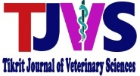 | Tikrit Journal of Veterinary Science | 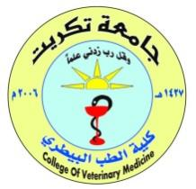

Histomorphology and Histochemical Study of the Spleen in Postnatal Puppies

Hesham …….¹, Hesham …….², and Hesham …….³

¹Department of …………, Veterinary Medicine College, University of Tikrit, Tikrit, Iraq
²Department of …………, Veterinary Medicine College, University of Tikrit, Tikrit, Iraq
³Department of …………, Veterinary Medicine College, University of Tikrit, Tikrit, Iraq

A r t i c l e i n f o.  Article history:  -Received:  -Received In Revised Form:  -Accepted:  -Available online:  Keywords:  Citrus limon; Methanolic extract; Rabbits; Hematological parameters; Platelet indices; Lipid profile; Liver enzymes.  ـــــــــــــــــــــــــــــــــــــــــــــــ  Corresponding Author:  Name: Hesham ……..  E-mail:  00000000@tu.edu.iq  Tel: 078200000000 | ABSTRACT  Background: Medicinal plants and their bioactive compounds have attracted increasing attention as potential natural supplements in veterinary medicine. Citrus limon peel contains several biologically active compounds that may influence hematological and biochemical parameters.  Aim: This study aimed to evaluate the effects of methanolic Citrus limon peel extract on selected hematological, platelet, and biochemical parameters in healthy male rabbits.  Materials and Methods: Ten healthy male rabbits were randomly divided into two groups: a control group and an extract-treated group, with five animals in each group. The treated group received 50 mg/kg body weight of methanolic Citrus limon peel extract orally once daily for 60 days. Blood samples were collected to assess hematological indices, platelet parameters, lipid profile, and liver and kidney function markers.  Results: The administration of Citrus limon peel extract was associated with changes in selected platelet indices, lipid profile parameters, and liver enzyme activities compared with the control group. The observed effects varied among the examined biochemical and hematological parameters.  Conclusions: Methanolic Citrus limon peel extract may influence selected hematological and biochemical parameters in rabbits. Further studies involving larger sample sizes and different doses are required to clarify its potential biological effects and safety.

INTRODUCTION
The spleen is an important lymphoid organ that develops and grows throughout the life of an animal. Its structural development is closely associated with the growth of the body and the maturation of the lymphatic system (Ali, 2026). The lymphatic system consists of cellular and vascular components that work together to support lymphoid tissue organization and lymph circulation. The cellular component includes lymphoid organs, such as the spleen and thymus gland, as well as lymph nodes, whereas the vascular component comprises the lymphatic vessels (Ali et al., 2026).
Lymphatic vessels are responsible for collecting and transporting lymph from the surrounding tissues toward the lymphatic circulation. In higher mammals, lymph is collected through thin lymphatic capillaries that extend from the limited area and connect with larger lymphatic vessels. This organization contributes to the movement of lymph throughout the body (Ali and Qussai, 2026).
The relationship between lymphoid organs and lymphatic vessels is essential for understanding the organization of the lymphatic system. The spleen, thymus gland, lymph nodes, and lymphatic vessels represent interconnected components of this system, with each component contributing to its structural and functional organization (Ali et al., 2026).
MATERIAL AND METHOD
Ethical approval
The Scientific Ethical Committee of the College of Veterinary Medicine, University of Diyala, Iraq, approved this study. Approval No. (26/2026).
Statistical Analysis:
The Statistical Packages of Social Sciences -SPSS (2019) program was used to detect the effect of difference age groups in parameters study. Least significant difference-LSD test ANOVA one way) was used to significant compare between means (0.05 probability) in this study.
Anatomical study
Bitches after parturition in the farm of Veterinary College of Diyala University take the puppies at 2, 8 weeks, and are weighed using an electronic sensitive scale; the weights were 1499,3 ±1.22 g, 2132,1± 0.130, 3901 ± 0.30 g, respectively.
Histological study
The second group, after removing the specimens, washed with distilled water then the small pace of the spleen fixed by 10% formalin and Bous solution.
RESULTS
Anatomical results
The spleen in puppies is located in the anterior abdominal cavity on the left side in the lateral side of the abdominal wall and related with the liver and stomach dorsally, jejunum ventrally, and the abdominal wall laterally (Figure 1), it was situated on the parietal surface of the stomach and was observed the caudal end of the spleen on the visceral surface of the stomach in left side (Figure 1).
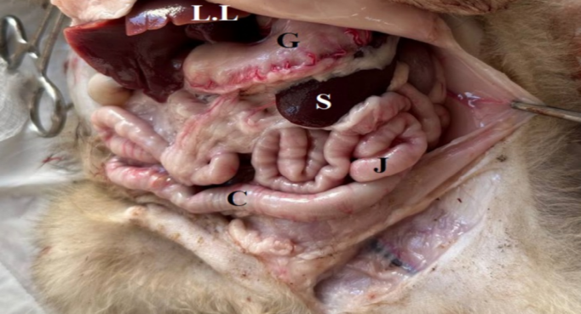

Fig. 1. Photography of the Abdominal cavity of puppies at 2-week (A): illustrated the position spleen (S), in left side, stomach (G) liver lobes (LL), Jejunum (J), colon (C).
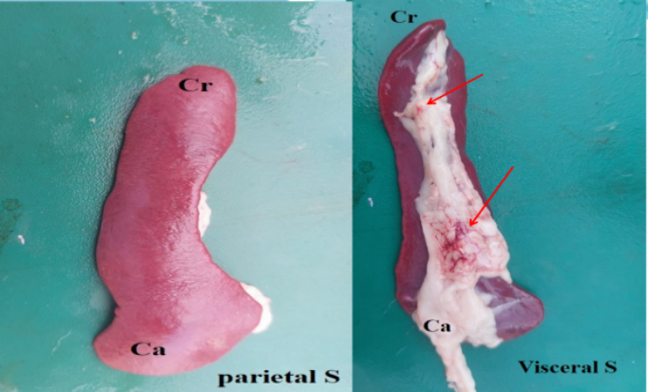

Fig. 2. Photography of the spleen (S) of puppies at 4 weeks as illustrated the parietal surface and visceral surface, hillus (red arrow).
The spleen was elongated, Crescent in shape, brown-reddish in color, it had two surfaces (parietal and visceral) (Figure 2), The parietal surface was concave, curved, and smooth (Figure 2 A), whereas the visceral surface had the hilus. (Figure 2 B), the weighted 10.87 ±2.77g,12.16 ±2.67g and 16.60 ±3.94. The body of the spleen has two ends (cranial and caudal), the wide cranial ends were 12.39 ±3.55 mm,12.99 ±2.74 mm, and 13.12 ± 4.76 mm, respectively, whereas the caudal ends19.78 ±2.25, mm,20.6 ±4.98 mm, and 25.2 ±0.57 mm, respectively. The caudal end is wider than the cranial. But there were no differences in shape and color between the spleens at three weeks of age. Whereas the thickness of the spleen was not uniform in all body, it is thicker in caudal end the cranial endless the body (Table 1 and Figure 2).
The branched inside the parenchyma, which subdivided into multiple branches at the hilum of the spleen, characterize have hillus along the body receive the blood through splenic artery which raise from celiac artery, the spleen related with the jejunum, stomach (Figure 3).

Table 1. The measurement of the spleen of the puppies at three (2,4 and 8) weeks of ages
Parameters | Mean ± SD |  |  | L.S.D.
Parameters | 2 weeks | 4 weeks | 8 weeks | L.S.D.
Length of spleen (mm) | 8.20 ±0.67 b | 9.32 ±2.67 b | 18.072 ±4.45 a | 2.901 *
Weight of the spleen (g) | 10.87 ±2.77 b | 12.16 ±2.67 b | 16.60 ±3.94 a | 3.047 *
Thick of body (mm) | 4.52 ±1.32 b | 6.55 ±2.95 a | 6.70 ± 2.66 a | 1.895 *
Thick carinal end (mm) | 12.39 ±3.55 a | 12.99 ±2.74 a | 13.12 ± 4.76 a | 2.077 NS
Thick caudal end (mm) | 19.78 ±2.25 a | 20.6 ±4.98 a | 25.2 ±0.57 b | 4.029 *
Means having with the different letters in same row differed significantly. * (P<0.05).

Histological results
The spleen in puppies is enclosed by a thick capsule, consisting of two layers outer layers consist of connective tissue, consisting of collagen, elastic, and reticular fibers and the inner layers are composed of smooth muscle fibers. The parenchyma of the spleen is similar to most mammalian spleens, consisting of white nodules (white pulp) (Fig. 5), which is embedded red with matrix known as red pulp. Red pulp is a highly vascular tissue that receives blood by the splenic artery enters the spleen through hillus and anastomosis. A few branches (arterioles) are surrounded by fibrocollagenus sheath. These vessels known as central arterioles, the tissue around them known as periarterioles and demonstrate the sinusoids with different sizes, lined by endothelial cells (Fig.6) and containing numerous cells such as macrophage, plasma cells, cells of periaterial zone, White pulp, composed of the lymphoid aggregate of T-cells, surrounds the fibro collagenous sheath these vessels know central arterioles, which form the periarteriolar lymphoid sheath (PALS).
DISCUSSION
In the current study, the spleen crescent (fusiform) in shape is similar to that of the cat (Ali and Qussai, 2026) and golden Hamster (Ali, 2026). These results differ from those of previous studies in sheep (Ali et al., 2026).
CONCLUSION
The spleen in puppies is similar to the spleen in farm animals; there is no present any demarcating between the structures. The spleen is characterized by highly vascular tissue (blood sinusoids containing sinuosoids) and consists of lymphatic tissue responsible for immune defence mechanism for the viscera of abdomen.
Conflict of interest
The authors assert the absence of any conflicts of interest.
Acknowledgements
The authors express gratitude to the members of the Department of Anatomy & Histology, College of Veterinary Medicine, University of Diyala, for their collaboration.
Declaration of interests
The authors have no conflicts of interest to declare.
Funding Sources
This research received no specific grant from any funding agency in the public, commercial, or not-for-profit sectors.
Publication consent
The authors agree to publication.
Data and material availability
All data analyzed during this study are included in this article.
Author contribution
The authors contributed equally to the article.
REFERENCES
Bancroft, A. J., McKenzie, A. N., & Grencis, R. K. (1998). A critical role for IL-13 in resistance to intestinal nematode infection. The Journal of Immunology, 160(7), 3453–3461. doi:org/10.4049/jimmunol.160.7.3453
Brendolan, A., Rosado, M. M., Carsetti, R., Selleri, L., & Dear, T. N. (2007). Development and function of the mammalian spleen. BioEssays, 29(2), 166–177. doi:org/10.1002/bies.20528
Das, S. K., Alam, M. S., Islam, M. N., & Awal, M. A. (2005). Histology of the spleen of indigenous dog (Canis familiaris) of Bangladesh. Bangladesh Journal of Veterinary Medicine, 3(1), 59–61. doi:org/10.3329/bjvm.v3i1.11356
George, D., & Mallery, P. (2019). IBM SPSS Statistics 26 step by step: A simple guide and reference (16th ed.). Routledge. doi:org/10.4324/9780429056765
Khalel, E. M. (2010). Anatomical and histological study of the spleen in Iraqi sheep (Awasi sheep). Basrah Journal of Veterinary Research, 9(2), 163–171. doi:org/10.33762/bvetr.2010.55061
Mebius, R. E., & Kraal, G. (2005). Structure and function of the spleen. Nature Reviews Immunology, 5(8), 606–616. doi:org/10.1038/nri1669
Young, B., & Heath, J. W. (2000). Wheater’s functional histology (4th ed.). Churchill Livingstone, London.

دراسة مورفولوجية وكيميائية نسيجية للطحال في الجراء بعد الولادة

هشام منعم نصيف ¹, رباب عبد الامير ناصر ²
^{2،1} فرع التشريح وعلم الأنسجة، كلية الطب البيطري، جامعة ديالى، العراق

الملخص
خلفية البحث: حظيت النباتات الطبية ومركباتها الفعالة حيويًا باهتمام متزايد بوصفها مكملات طبيعية محتملة في مجال الطب البيطري. ويحتوي قشر الليمون على العديد من المركبات الفعالة حيويًا التي قد تؤثر في المؤشرات الدموية والكيميائية الحيوية.
الهدف: هدفت هذه الدراسة إلى تقييم تأثير المستخلص الميثانولي لقشر الليمون في بعض المؤشرات الدموية، ومعايير الصفائح الدموية، والمؤشرات الكيميائية الحيوية لدى الأرانب الذكور السليمة.
المواد وطرق العمل: استُخدمت عشرة أرانب ذكور سليمة، وقُسّمت عشوائيًا إلى مجموعتين: مجموعة سيطرة ومجموعة معاملة بالمستخلص، بواقع خمس حيوانات في كل مجموعة. تلقت مجموعة المعاملة المستخلص الميثانولي لقشر الليمون بجرعة مقدارها ٥٠ ملغم لكل كيلوغرام من وزن الجسم، عن طريق الفم، مرة واحدة يوميًا لمدة ٦٠ يومًا. جُمعت عينات الدم لتقييم المؤشرات الدموية، ومعايير الصفائح الدموية، وملف الدهون، ومؤشرات وظائف الكبد والكلى.
النتائج: ارتبط إعطاء مستخلص قشر الليمون بحدوث تغيرات في بعض مؤشرات الصفائح الدموية، ومعايير ملف الدهون، وفعاليات إنزيمات الكبد مقارنةً بمجموعة السيطرة. وقد تباينت التأثيرات الملحوظة بين المؤشرات الدموية والكيميائية الحيوية التي جرى فحصها.
الاستنتاجات: قد يؤثر المستخلص الميثانولي لقشر الليمون في بعض المؤشرات الدموية والكيميائية الحيوية لدى الأرانب. وهناك حاجة إلى إجراء دراسات إضافية تتضمن أعدادًا أكبر من الحيوانات وجرعات مختلفة لتوضيح تأثيراته البيولوجية المحتملة ومدى سلامته.
الكلمات المفتاحية: قشر الليمون؛ المستخلص الميثانولي؛ الأرانب؛ المؤشرات الدموية؛ مؤشرات الصفائح الدموية؛ ملف الدهون؛ إنزيمات الكبد.

